Return to School Policy
for ISD Primary

Version 20 May 2020

Table of Contents
Update blended learning 20 May 2020 4
Schedule from 25 May to 5 June 2020 4
Adjusted school timings 5
Blended learning 7
Childcare and After School Care 8
When is your child not allowed in school? 8
Staff guidelines and absences 9
Hygiene measures 9
Childcare and After School Care 10
When is your child not allowed in school? 10

Update blended learning 20 May 2020

Until 5 June we will continue with the blended learning program we are currently using.
That means that children will go to school for half days in half groups according to a specific schedule. We have included the schedule for the next two weeks. Whether your child is in the A group or B group is in the other document attached ‘groupings blended learning’.
We keep the groups separated to adhere to strict safety measures. It is important that children do not switch groups during this period. If you choose to keep your child at home during this period, please inform the Head of School Sander Raaphorst (sraaphorst@isdelft.nl).

Updates in this policy:
- Schedule from 25 May to 5 June 2020
- The learning will shift more and more to physical learning in school.
Activities in school can follow up at home or online activities can be followed up at school.
- Specialist teachers are scheduling in their lessons in school from this week. Therefor they will not post any online activities on Seesaw anymore.
- Staff must consider social distancing rules. This means that all adults in school should to stay 1.5 metres apart from each other. Staff will also try to keep 1.5 metres distance from the children as much as possible. Children do not necessarily have to keep distance from each other. (Government and RIVM guidelines)

Schedule from 25 May to 5 June 2020

 | Mon 25 May | Tue  26  May | Wed  27  May | Thu  28  May | Fri  29  May | Mon  1 June  (Pentecost) | Tue  2 June | Wed  3 June | Thu  4 June | Fri  5 June
1/2A-A | X |  | X |  | X |  | X |  | X
1/2A-B |  | X |  | X |  |  |  | X |  | X
1/2B-A | X |  | X |  | X |  | X |  | X
1/2B-B |  | X |  | X |  |  |  | X |  | X
1/2C-A | X |  | X |  | X |  | X |  | X
1/2C-B |  | X |  | X |  |  |  | X |  | X
3-A | X |  | X |  | X |  | X |  | X
3-B |  | X |  | X |  |  |  | X |  | X
4A-A | X |  | X |  | X |  | X |  | X
4A-B |  | X |  | X |  |  |  | X |  | X
 | Mon 25 May | Tue  26  May | Wed  27  May | Thu  28  May | Fri  29  May | Mon  1 June  (Pentecost) | Tue  2 June | Wed  3 June | Thu  4 June | Fri  5 June
4B-A | X |  | X |  | X |  | X |  | X
4B-A |  | X |  | X |  |  |  | X |  | X
5-A | X |  | X |  | X |  | X |  | X
5-B |  | X |  | X |  |  |  | X |  | X
6-A | X |  | X |  | X |  | X |  | X
6-B |  | X |  | X |  |  |  | X |  | X
7-A | X |  | X |  | X |  | X |  | X
7-B |  | X |  | X |  |  |  | X |  | X

Adjusted school timings
To make sure that we organise and structure the number of children coming into school in the hallways and on the playground, we have adjusted the timings for the start and ending of the day and snack/ break. We have also changed the timings of dropping off and picking up the children according to the following schedule:

 | Drop off | Start | Pickup | Outside play
1/2A | 8-8.15am | 08:15 | 11:45 | Between 8.15- 9.25 and/or after 10.30
1/2B | 8-8.15am | 08:15 | 11:45 | Between 8.15- 9.25 and/or after 10.30
1/2C | 8-8.15am | 08:15 | 11:45 | Between 8.15- 9.25 and/or after 10.30
3 | 8.15-8.30 | 08:30 | 12:00 | 9:50 – 10:05
4A | 8.15-8.30 | 08:30 | 12:00 | 9:50 – 10:05
4B | 8.15-8.30 | 08:30 | 12:00 | 9:50 – 10:05
5 | 8.30-8.45 | 08:45 | 12:15 | 10:10 – 10:25
6 | 8.30-8.45 | 08:45 | 12:15 | 10:10 – 10:25
7 | 8.30-8.45 | 08:45 | 12:15 | 10:10 – 10:25

During this period of blended learning, parents are not allowed in school. Exceptions are emergencies or specific appointments with staff.
For dropping off and picking up children we have reserved the Landbergstraat (road between ISD and the bicycle garage). The parking area in front of the school is closed for dropping off and picking up children. Siblings will be dropped off at the time of the youngest and picked up at the time of the oldest. Children will stay with their own class teacher in the meantime.

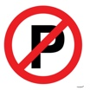
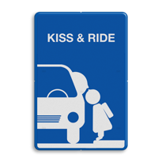
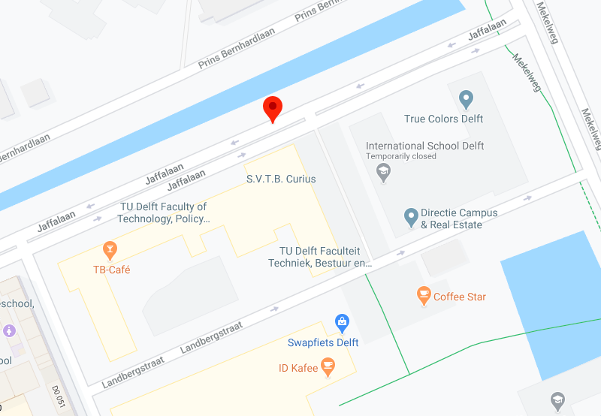

For dropping off we ask you to Kiss and Ride only and follow instructions from staff who will guide your children safely in school and to their class.
Any other form of transportation will also gather at the Kiss and Ride area.

Picking up children will also happen according to the timetable in the schedule above. Parents should line up (in car or with bicycle) on the Landbergstraat. Teachers and staff will bring the children out and safely direct the children to the parents. Please drive away as soon as you have picked up your child. Always follow instructions of ISD staff.

Blended learning

After the May holiday we will shift from remote learning to blended learning. This means that we are trying to find a balance between having children physically in school and remote teaching with the platforms that we currently have in place.

The focus of the physical learning in school will (at first) be on the social and emotional well-being of the children and providing opportunities to connect to their peers and teachers at school again. Teachers, specialist teachers and support staff will also organise learning activities and/ or support with the online learning activities. This can be in school or the surrounding area. The learning will shift more and more to physical learning in school.
Activities in school can follow up at home or online activities can be followed up at school.
Specialist teachers are scheduling in their lessons in school from this week. Therefor they will not post any online activities on Seesaw anymore.

We ask all parents to prepare their children for the changes in the school situation by talking to them about the hygiene and distancing rules towards other adults.

Staff will further elaborate the content of the learning in school in the next few days or directly after the holiday. Parents will be informed by the class teacher about the content of the learning at school and the combination with remote learning.

To ensure a smooth transition back to school and to ensure the social distancing rules between teachers and children please make sure that the children are in “easy” clothing (easy to zip up clothing and easy to put on shoes). Make sure that you prepare a snack that the child can access easily and eat independently. Children should bring their own writing materials if possible so we can avoid sharing.
Children will have their snack in school but will eat lunch at home.
All inside activities in other buildings other than our school building (gym) are cancelled. Gatherings of large groups (like assemblies) are cancelled.
In the afternoon staff will work on the remote learning platform and on the preparation for the physical learning the next day.

There will be special attention for SEN and EAL children. The Learning Support department will consult with the teachers on the approach and organisation.

Childcare and After School Care

Children of parents in vital professions can be in school on requested days. Please let us know if that is the case and we will approach you individually.
Childcare and after school care are available for children that have already signed up with True Colors. After school care is available only on the days that your child is physically in school.
If your child needs after school care, staff of ISD will make sure that your child is cared for during the time school is out and the beginning of the after school care (see school timing schedule). Please let us know if you need this service.

When is your child not allowed in school?
If your child show any symptoms related to Covid-19 like:
- Cold
- Running nose
- Fever
- Regular sneezing/ coughing

If a family member is sick or shows any symptoms as mentioned above the child is not allowed in school. You will be called to pick up your child as soon as possible from school. In the meantime, the child will be isolated from other children and staff.
Children with vulnerable health or/and in risk-groups, or with family with vulnerable heath or/and in risk-groups are advised not to come in school.

If your child has other health concerns with symptoms like Covid-19
(Asthma -coughing, allergies- sneezing) your child is allowed into school. Please provide us with a medical statement from your doctor.

If whole families or family members are traveling from other countries into the Netherlands, you are advised not to send your child to school for two weeks. If after those two weeks your child or family members does not show any symptoms, he/she can come to school.

Staff guidelines and absences
All staff members are expected to be in school on their regular working days.
Additional requests related to this expectation, such as childcare issues, are to be discussed with the Head of School.

Staff must consider social distancing rules. This means that all adults in school should to stay 1.5 metres apart from each other. Staff will also try to keep 1.5 metres distance from the children as much as possible. Children do not necessarily have to keep distance from each other. (Government and RIVM guidelines)

If work can be done from home (like remote, learning preparations in the afternoon) please do so. We want to avoid having too many adults in school. This means we can also implement a schedule for attendance and tasks.

Staff members with health concerns or symptoms related to Covid-19 stay at home.
If a family member is sick or shows symptoms related to Covid-19, staff members stay at home. Staff members with symptoms can be tested for Covid-19.

Staff members that are in a risk group (https://lci.rivm.nl/kwetsbare-medewerkers)
should work from home.

Staff members with a family member in the risk group should consult with the Head of School about attendance and expectations.

Staff absences for sickness will be covered by another member of the team or with substitute teachers if available.

Hygiene measures
During the school closure, our school was cleaned by our cleaning company Asito. We are in contact with them about the extra hygiene measures after the holiday. During the school day we will make sure we have additional hygiene and cleaning measures in place. We will also make sure that specific areas like toilets, doorknobs, windows will be cleaned throughout the day.
Before the school closure we ordered hygienic supplies (soap, paper towels, hand gels). These are still available for our children and staff to use.

We will have specific attention for hygienic daily routines and practices.
We will also include the children in discussions about these routines and practices and how they can keep themselves and their environment safe and healthy.

